Supporting pollution preparedness and response in Croatia

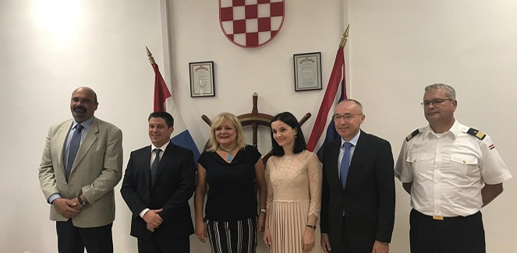

In addition to the latest RPAS services, EMSA has made specialised marine pollution response equipment available to the Croatian authorities including a trawl net, and confinement and recovery system. Meanwhile, Croatian ministries sign agreements to boost coast guard cooperation at national level. EMSA Executive Director in the presence of Minister of Defence and Deputy PM of Croatia - Damir Krstičević; Ministry of Maritime Affairs, Transport and Infrastructure - Oleg Butković; Minister of Agriculture overseeing fisheries - Marija Vučković; Deputy Minister of Sea, Transport and Infrastructure – Siniša Orlić; and Commander of the Croatian Navy – Commodore Ivo Rafanelli.